Installing Eclipse and Maven on a VDA

Obtaining and Accessing the VDA
You first need to order the “KARLSKRONA ZONE ACCESS” and “KARLSKRONA VDA” products through GORDON. It will take a couple of days after approval then you will be able to access it at https://hubseka.ericsson.se/. The first time you login you will see this:
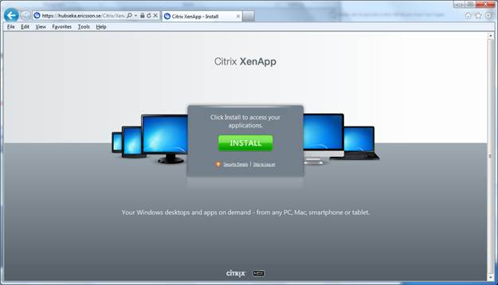
Clicking Install will take you to a Citrix site where you need to download and install the Citrix Receiver. Select Citrix Receiver / Receiver Easy Install in the Find Downloads box on the left of the screen then click Find.

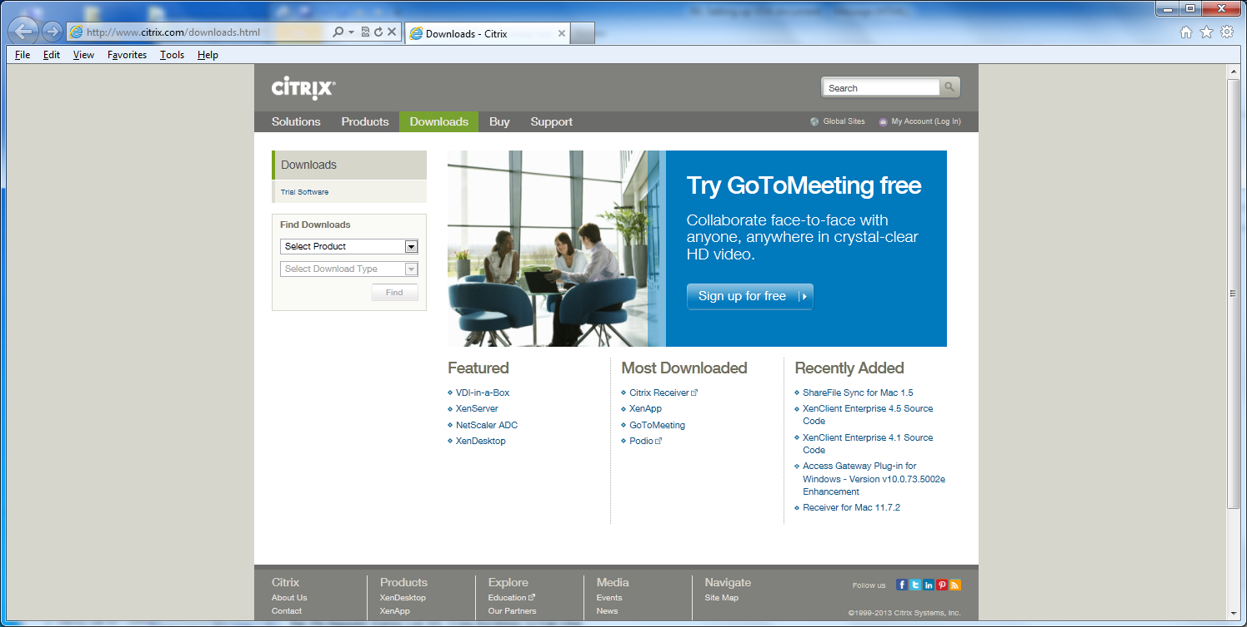
Then select the Detect my device and install Receiver link. 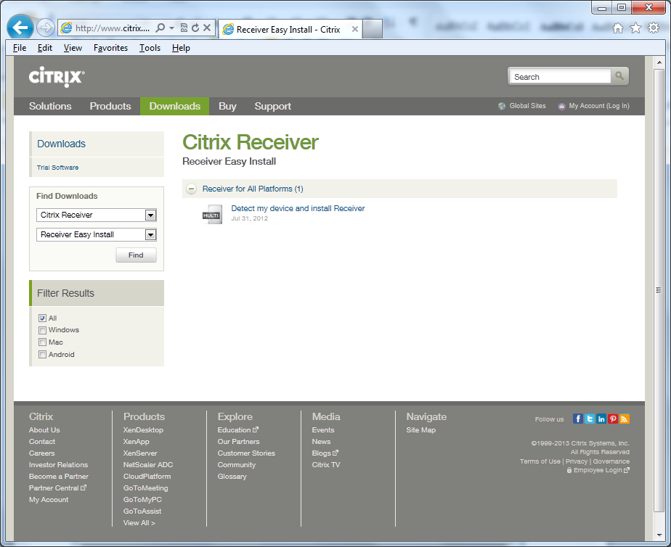
Then Click Download Receiver for Windows button on screen.
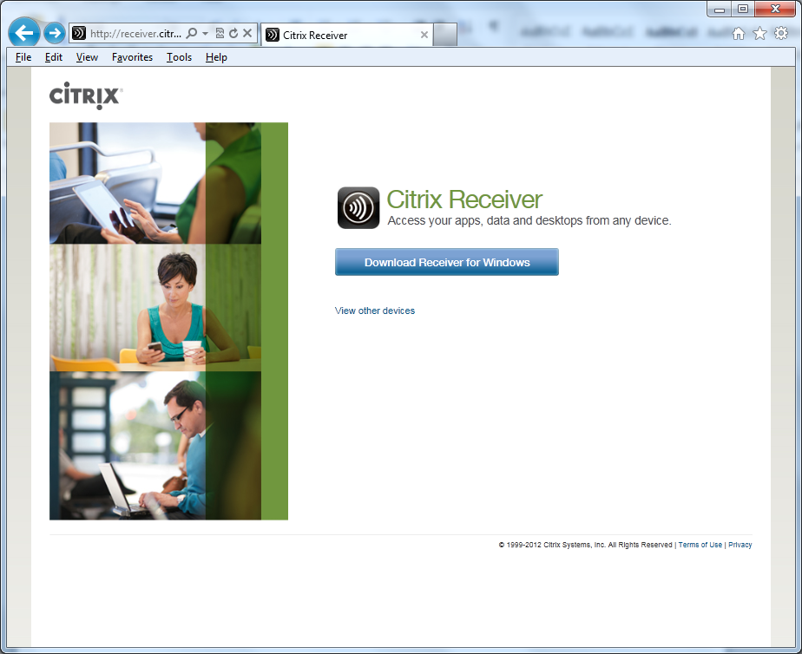
Agree to the license aggreement and click Continue button.
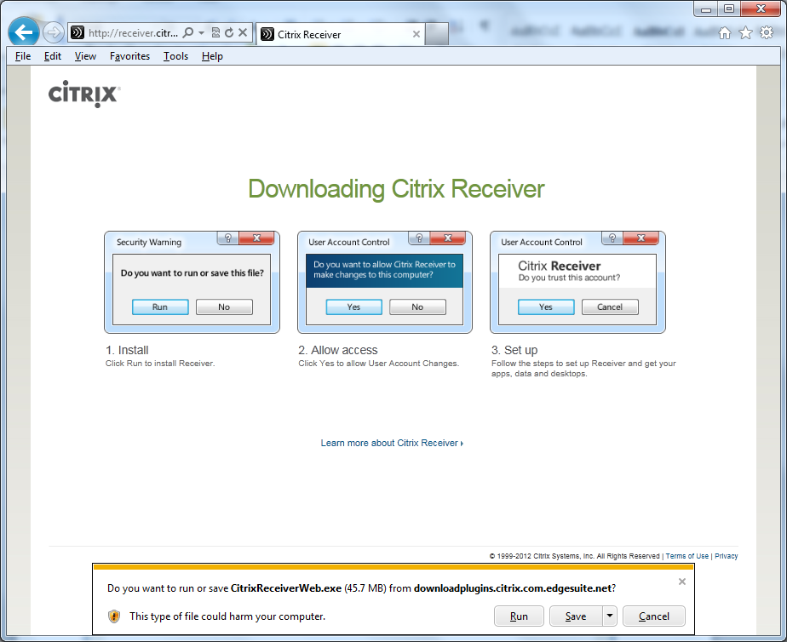
Click Yes on the User Account Control screen to bring up the Citrix Receiver screen.
When that has been successfully installed then navigating back to https://hubseka.ericsson.se/ you will see the following screen and you can login with your usual signum and passwd.
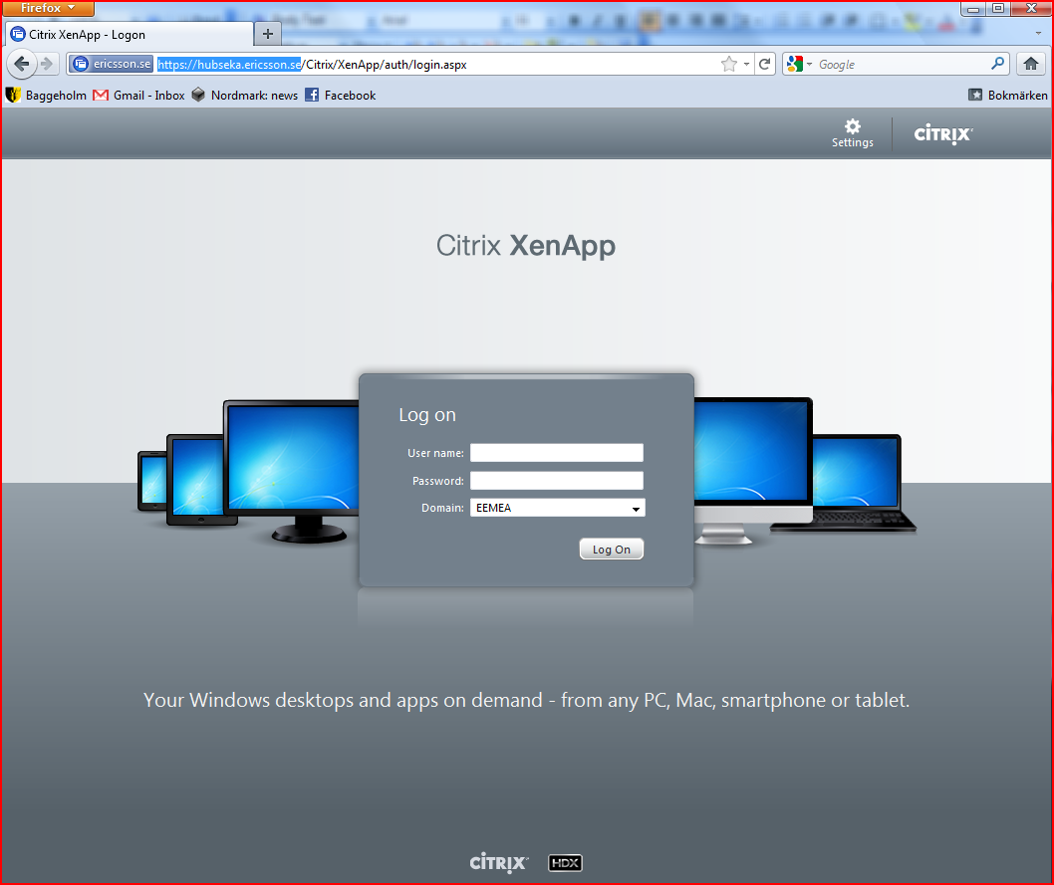
For more information try https://ericoll.internal.ericsson.com/sites/HubKarlskrona/Pages/Support.aspx

Installing and Configuring Cygwin
If you want to run maven from the command line you may want to install Cygwin on your VDA. It may be possible to do everything you need to do from within Eclipse so you may not want to do this step.
If you don’t want Cygwin, skip to the next section.
Go to http://www.cygwin.com/ and click on the link to setup.exe.
For the Root Directory choose C:\cygwin
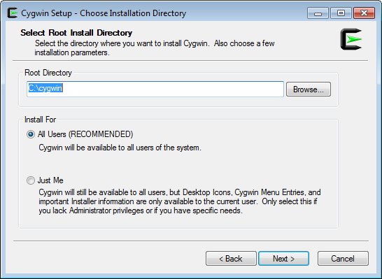

For Internet Connection select Use Internet Explorer Settings:
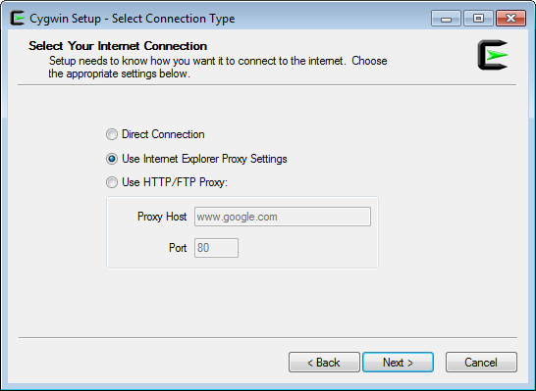

If all goes well you will get the list of download sites, choose ftp://ftp.sunet.se:
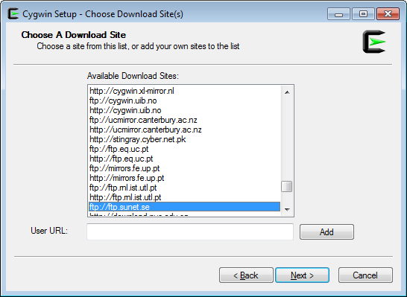
You can then select packages to install:
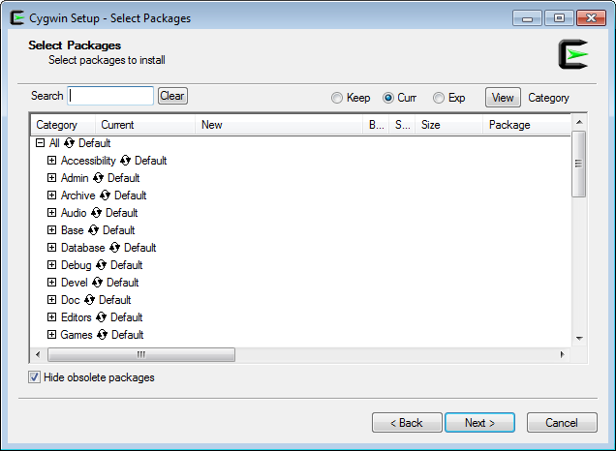

Suggested packages:
- git
- bash
- wget, curl
- openssh
- vi
- X11

NOTE: After cygwin is installed and created a desktop icon, you need to change the target command to:

C:\cygwin\bin\bash.exe --login -i

Creating useful directories
By now you should have a working Cygwin shell. Open it and create the following directories if they don’t exist already (where <signum> is your E/// login name):
- /opt
- /home/<signum>
- /home/<signum>/NGEE
- /home/<signum>/.m2
- /home/<signum>/.ssh
- /home/<signum>/bin

Installing Maven
You will need to get the latest *.bin.zip file from http://maven.apache.org/download.cgi. Look for the apache-maven-<xx>-bin.zip file on the webpage. Clicking on the downloaded file will open it in Explorer. Copy the apache-maven-xx folder and paste it in C:\cygwin\opt

Setting up ~/.bashrc
You can then setup your home directory with .bashrc just how you like it. This is what mine looks like:

$ cat ~/.bashrc
#!/bin/bash

# Configure cygwin
export CYGWIN=nodosfilewarning

# Setup Maven environment vars
export M2=/opt/apache-maven-3.0.5/bin
export M2_HOME=/opt/apache-maven-3.0.5
export JAVA_HOME="/cygdrive/c/Program Files/Java/jdk1.6.0_35"

# Setup proxy
export http_proxy=http://www-proxy.ericsson.se:8080

# Setup some nice aliases
alias ll='ls -al --color'

# Fixup the path
export PATH=$PATH:.:$HOME/bin:$M2
I also created a wrapper for Maven in my ~/bin directory:

$ cat ~/bin/mvn
#!/bin/bash

$M2/mvn --settings c:/cygwin/home/egilald/.m2/settings.xml ${@}

The –settings option is to make sure it uses the right directory to pick up its local settings file. There are a lot of places it can choose to look on the VDA, it is well worth explicitly telling Maven where to get this file.

Installing Eclipse

Preparation For Non-Cygwin Users
Your VDA will be setup with two disks C:\ and P:\.
If you decided not to install cygwin, then bring up a cmd window which will be at the P:\Users\<signum> directory already. Create the following directories (user command: mkdir <dir>):
- P:\Users\<signum>\NGEE
- P:\Users\<signum>\.m2
- P:\Users\<signum\.ssh

Create ~/.m2/settings.xml
The VDA environment is behind a firewall so Maven needs to be told about a proxy before it can reach the outside world and download artifacts to the local repository. You will need the following settings.xml file in either P:\Users\<signum>\.m2 or C:\cygwin\home\<signum>\.m2:

$ cat ~/.m2/settings.xml
<settings>
<localRepository>C:\cygwin\home\egilald\.m2\repository</localRepository>

<proxies>
<proxy>
<active>true</active>
<protocol>http</protocol>
<host>www-proxy.ericsson.se</host>
<port>8080</port>
<nonProxyHosts>localhost,*ericsson.se,*ericsson.com</nonProxyHosts>
</proxy>
</proxies>
</settings>

Installing Eclipse
You will now need to install Eclipse, a JDK, and various plugins. The simplest way to get the JDK is to use Control Panel -> Programs -> Get Programs (it is a sub link under the words Get Programs) then check “Oracle Java SE Development Kit 6 Update 35 (64-bit)”. This will automatically be installed to C:\Program Files without any more user interaction.
Note: *don’t* install Eclipse4Ericsson this way because you will get an old version (3.4.x).
Next you can get the latest Ericsson supported version of Eclipse from:
https://ericoll.internal.ericsson.com/sites/EECS/default.aspx

Look for the Download link on the webpage. Then follow Using and Installing EECS Eclipse -> Single-user Installs. Save the latest Windows 64-bit version and download it from the Europe Server. Clicking on the zip file will open it in an Explorer window. Copy and paste the eclipse folder to C:\Program Files.

In the working directory, you will need to create a start script (e.g. eclipse.bat) with at least the following (and adjust for your home directory path and where Java is installed):

set WORKSPACE_HOME="C:\cygwin\home\egilald\NGEE"
set JAVA_HOME="C:\Program Files\Java\jdk1.6.0_35\bin"

REM Eclipse runtime options
REM http://help.eclipse.org/indigo/index.jsp?topic=%2Forg.eclipse.platform.doc.isv%2Freference%2Fmisc%2Fruntime-options.html

start eclipse.exe -clean -data %WORKSPACE_HOME% -vm %JAVA_HOME%\javaw

Create a shortcut on the desktop and browse to the batch file that you just created above. Make sure the Start In information is correct (check Properties of the desktop shortcut). For example mine is: "C:\Program Files (x86)\eclipse".

Installing the Maven Eclipse plugin
In Eclipse, go to Help > Install New Software. Click on Add and enter the Maven Eclipse plugin update site:
http://download.eclipse.org/technology/m2e/releases
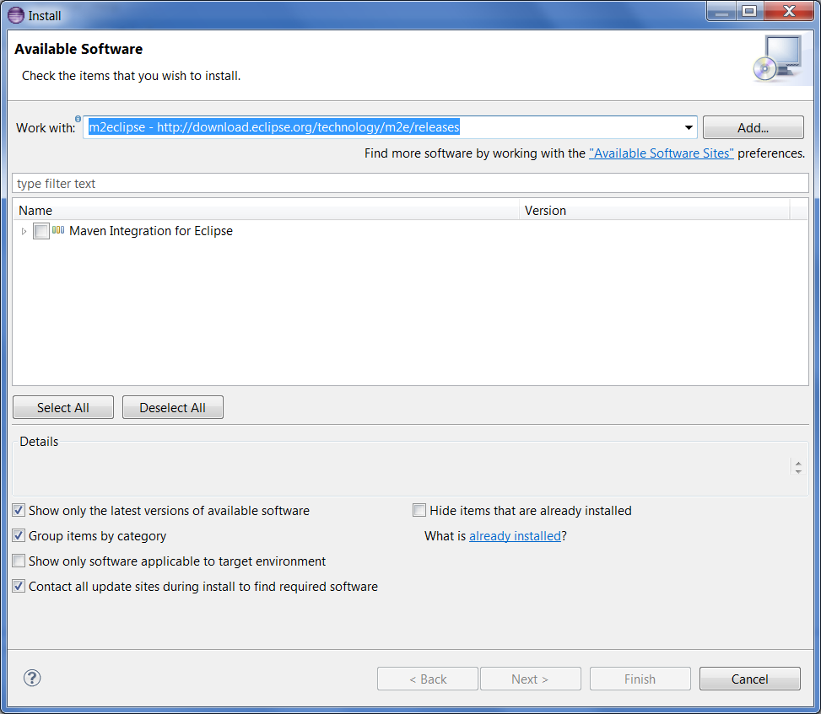
You can also visit the m2eclipse website for more instructions: http://eclipse.org/m2e/
Next you need to tell Eclipse where your Maven repository is installed. In Eclipse, go to Window > Preferences. Select the Java > Build Path > Classpath Variables page.
Click on the New button to add a new variable, and in the Name input box type M2_REPO.
In the Path input box, type the location or navigate to your maven repository.
The maven repo is installed by default in your home user directory in a folder called .m2, unless you have chosen to put it elsewhere. For example, mine is at C:\cygwin\home\egilald\.m2\repository

Install Collabnet Desktop

Install the Eclipse Collabnet Desktop as follows:
Click on Help -> Install New Software…, and then click on Add… in the top right corner, to add the entry for obtaining the software. The URL is, http://downloads.open.collab.net/eclipse/update-site/e4.2 which you add like this:

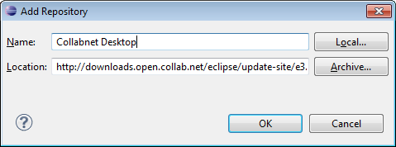

Click OK, and then select the following packages to install:

- Collabnet Desktop
- Eclipse Git Team Provider
- eReviewBoard
- eReviewBoard Integrations
- JGit

Click Next and so on, to complete the install. Dependencies will be installed automatically. Eclipse will prompt for a restart. Allow it to do that.

Link to Collabnet Eclipse Desktop
http://desktop-eclipse.open.collab.net/

Connect to eForge

- Window→Open Perspective→Other
- Select Collabnet then click OK
- On the left panel, right mouse click then New→Collabnet Site
- Expand “Add a new site” then select Collabnet TeamForge and click Next
- Fill in the fields
Description: eForge
URL: https://eforge.ericsson.se
- Put in your signum and password, and click next, then finish.
- Expand your eForge site. You should see NGEE for BOAT as one of your eForge sites. Expand the site.

Setting up SSH keys for Source Code

In order to access the source code repositories associated with the eForge project, you need to establish SSH keys. In Eclipse, click on Window ->Preferences -> General -> Network Connections -> SSH2. Click on the Key Management tab, then click on Generate RSA key. Select and copy the generated key to your clipboard, and leave Eclipse at that window as you will need to come back to this again later.

Then, in a browser window, go to
https://eforge.ericsson.se/sf/linkedapplication/do/viewSiteLinkedApplication?id=lapp1175
You can also find this page, by going to the main eForge site,
https://eforge.ericsson.se/sf/sfmain/do/home
and clicking on the “Gerrit” tab at the top.

Click on Settings at the top right corner, then SSH Public Keys on the menu down the left, then Add Key. Paste the key you just copied from Eclipse.
Go back to Eclipse and also save the generated key, with or without a passphrase (click on Save Private Key button). The filename should be id_rsa, save it in <$HOME>/.ssh

Setting up Git Configuration Parameters
Git needs certain information about yourself to check in code. In Eclipse, click on Window→Perferences→>Team→Git→Configuration→User Settings→Add Entry and add the following entries:
- Key=core.autocrlf, Value=true
- Key=user.email, Value=<Your Ericsson email address>
- Key=user.name, Value=<Your Ericsson signum>
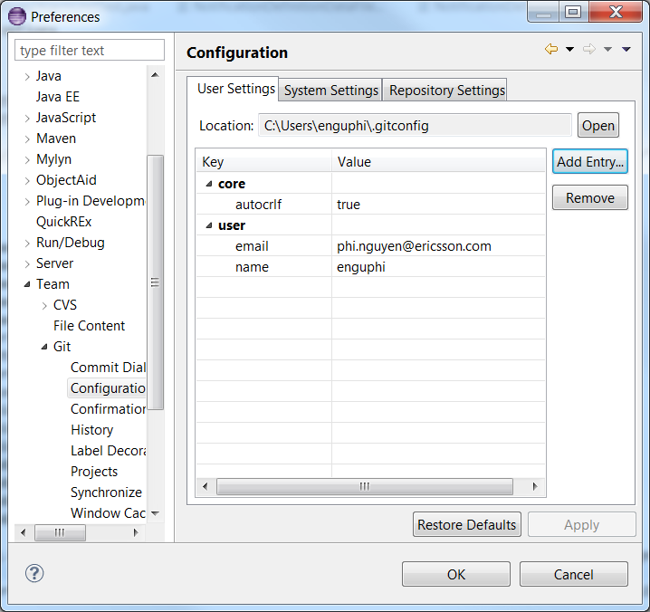

Checking Directory Use
I have found that it can be hard to pin down which directories Eclipse and Maven are using for the various configuration files and repositories and it is worth checking to make sure that the command line Maven and the Maven plugin in Eclipse are consistent.
There are two places to look in Eclipse. Both under Windows -> Preferences.
First look under Maven -> User Settings and make sure that the correct settings.xml file is being used. It should be the one we created earlier: <$HOME>/.m2/settings.xml
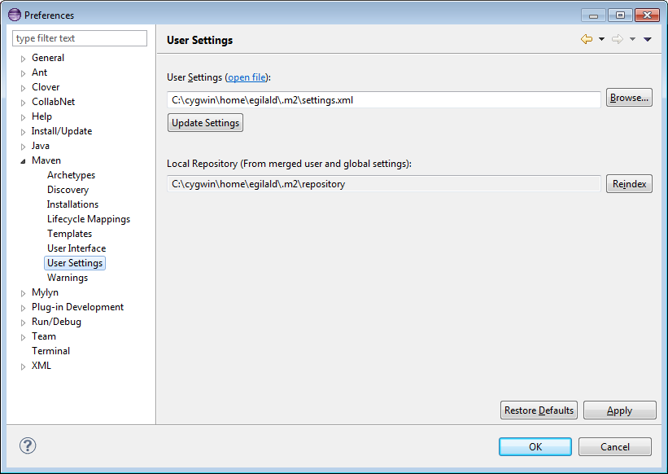
First check Java -> Build Path -> Classpath Variables and make sure that M2_REPO is pointing to <$HOME>/.m2/repository.
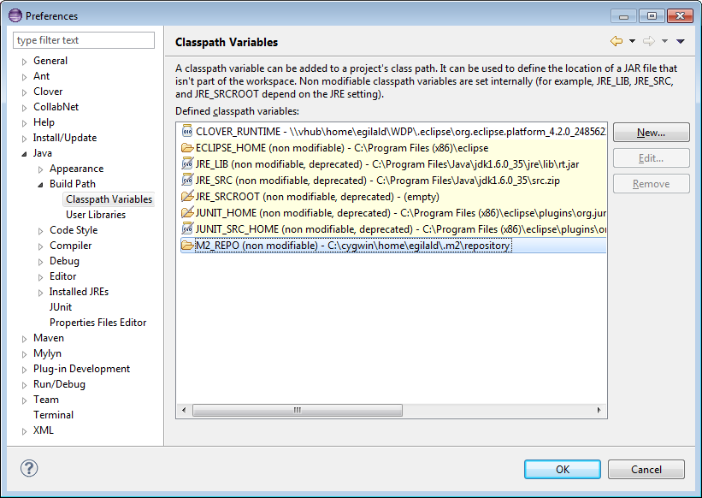

Accessing Source Code
In Eclipse, go to the Java Perspective. In the Package Explorer panel, right click and click Import. In the popup window, select Git/Projects from Git.
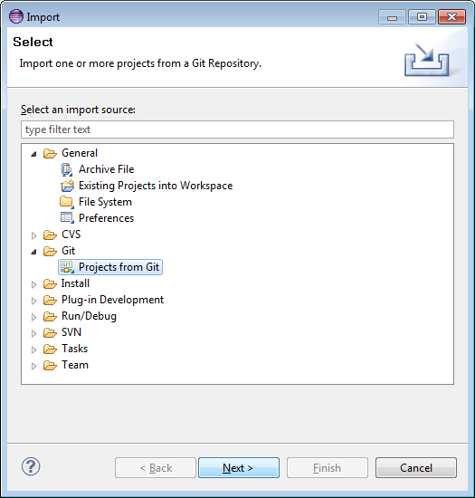

In the next pop-up, click TeamForge and Next,
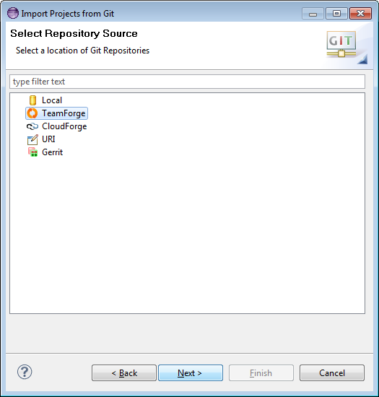

Then expand the eForge entry (this is the TeamForge site you created above).
This will display all eForge project – a long list. Scroll down to your project, expand it and select the Repository you want to import. Click Next.

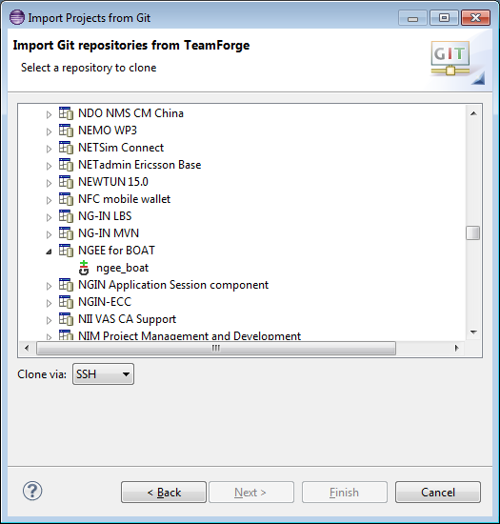

Select the branch you want to clone, click Next,
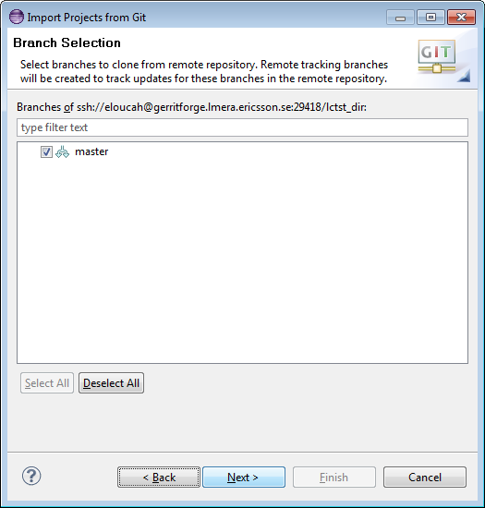

Make sure your local destination Git repository is the one you want and click Next.
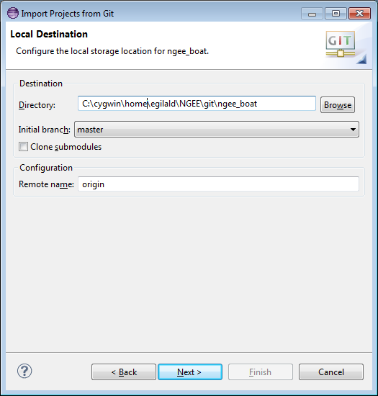

Depending on what was stored in Git, you can now import the Project. If the Project was stored as an Eclipse project, you can “Import existing projects”
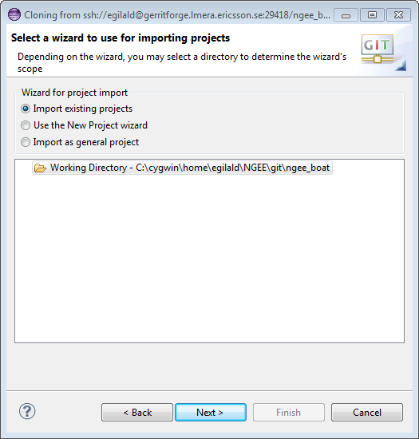

This will display the Eclipse Project in the local Git Repository:

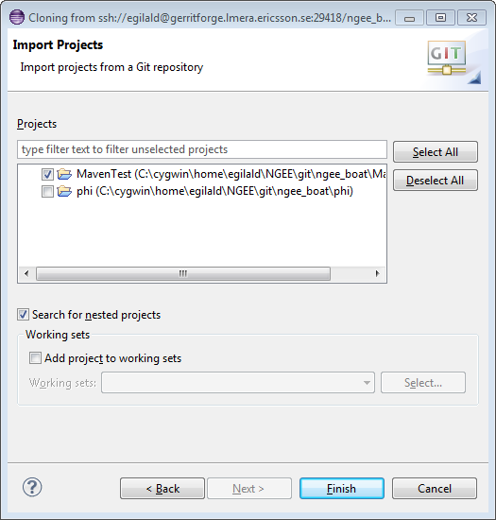

Click Finish, and you have the Project in Eclipse, linked to your local Git Repo.
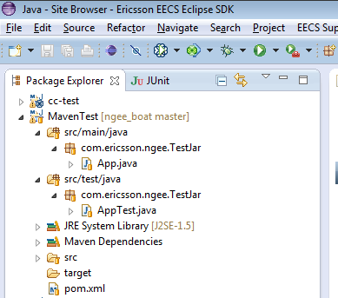

For more information on (Eclipse Git Plugin): http://wiki.eclipse.org/EGit/User_Guide

Installing JaCoCo Plugin
Go to Help -> Install New Software and add a new download site:
http://update.eclemma.org/
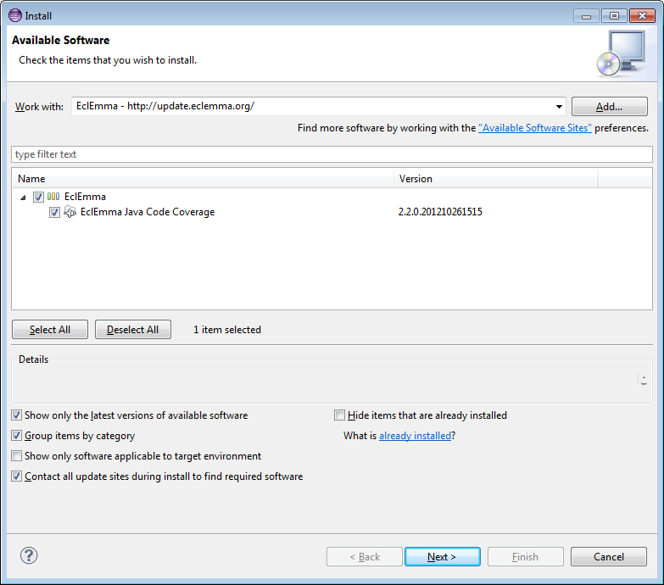
This will give you a new button in your taskbar that can be used to launch a code coverage test.
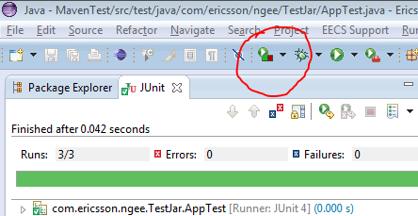
You will then be able to see the results of the code coverage analysis on your source classes in Eclipse.
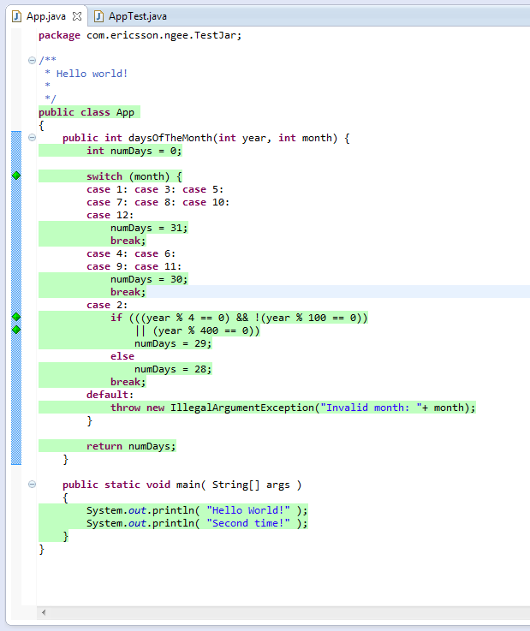
You also get a new tab where you can explore the code coverage results for the whole project and drill down on each class and method definition looking for problems.
